GIT (Distributed Version control system)

Git is a software for tracking changes in any set of files, usually used for coordinating work among programmers collaboratively developing source code during software development.

Git is **a DevOps tool used for source code management and is a version control system.**

It is a free and open-source version control system used to handle small to very large projects efficiently. Git is used to tracking changes in the source code, enabling multiple developers to work together on non-linear development.

Three structure architecture – Working, Staging, and Commit to Git Repository

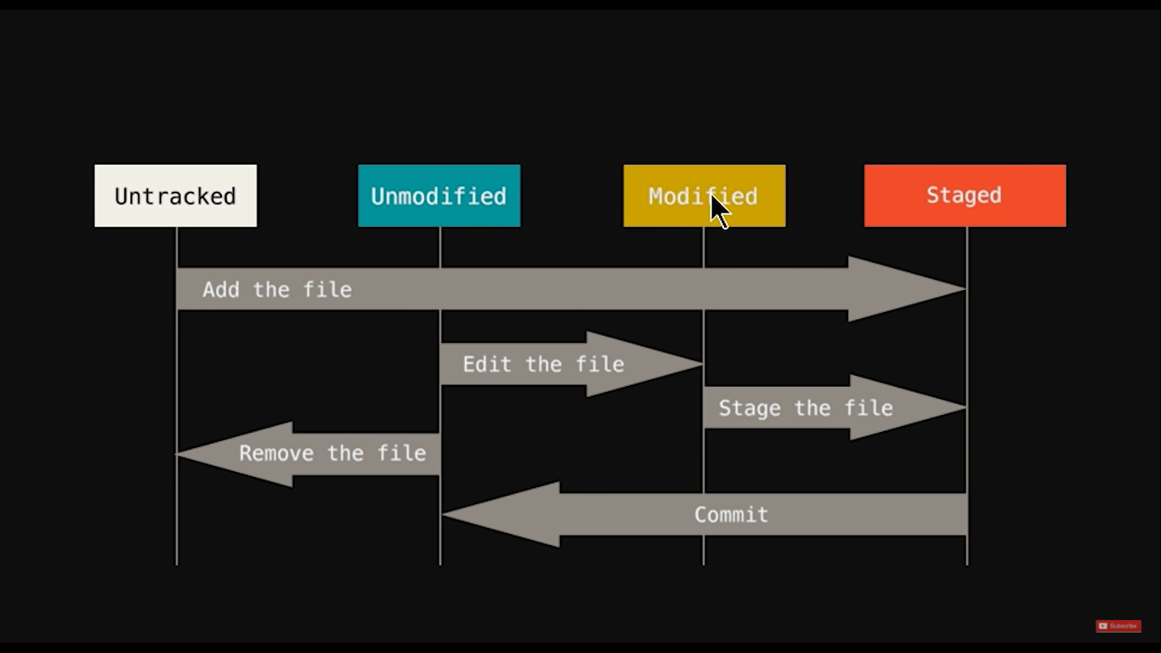

**COMMANDS** –

|  |  |
| --- | --- |
| Commands | Actions |
| cd | Home directory/ Change directory |
| pwd | Present working directory |
| git help | Provides list of all available commands |
| git config - - global user.name “xyz” | Creates a username (config command) |
| git config - - global user.email “xyz” | Registers email ID |
| git config - -global - -list | provides the details list of usernames and their config |
| git init | Git initialization (Creates a .git hidden file where it starts tracking all the files inside the folder) |
| git commit -a | Create snapshot |
| git commit –m “message” | creates initial snapshot of all the files in the staging area (Staging -> Commit) |
| git commit –a –m “message” | Creates snapshot (Directly commits the file that are tracked skipping the staging area) Files untracked will not get commit |
| git commit - -amend | Change/Edit an existing commit |
| git add <file name> | Moves that particular file from untracked to staging area |
| <git add - -a> or <git add a .> | Add all files from **UNTRACKED** to **STAGING** area directly |
| Git restore - -staged <File name> | Reverts the file back from staging to Unstage (Unmodified) |
| Git restore <file name> | Reverts changes in the working directory |
| git status | Check the status of the files created/modified |
| touch <file name> | Creates a file inside the directory |
| touch .gitignore | Creates a GIT IGNORE file (Adding files into this folder will prevent to further tracking) |
| git log | Shows the last commit details (Author/date/commit) |
| git log –p – (any number of last logs 1,2,3) | Shows the last ‘N’ no.of log files/commits |
| git log - -since=(X).(days/weeks/months) | Shows the log as per the filtered criteria |
| git checkout <file name> | Recovers the last saved file before modified |
| git checkout –f | Recovers/Matches ALL the last saved files before modified/edited (All files) |
| git branch <file name xyz> | Creates a branch (testing) which is separated from the branch master (prod); which is normally used for testing purpose |
| git checkout <branch name> | toggles between branch master and branch |
| **git checkout master** | Switch to master branch |
| **git checkout –b <branch name>** | Creates a new branch and directly takes you in it |
| git merge <branch name> | Merges the current branch to branch master |
| Git branch | Shows the details of all the branches created |
| Git branch - - merged | Shows the branches that are merged with master |
| Git branch - - no-merged | Shows the branches that are not merged yet |
| Git branch –d <branch name> | Gives an warning error before deleting the branch |
| Git branch –D <branch name> | Deletes the particular branch without any warning |
| Git branch –v | Shows the branches and their last commits with message |
| git clone <URL> | Clones the code from the repo and creates a folder inside the local directory |
| git diff | Shows exact difference of what was modified (Compares working tree with staging area) |
| git diff - - staged | Compares the previous commits with current staging area |
| git rm <file name> | deletes the particular file from directory |
| **git rm - - cached <file name>** | Undo a particular file from tracking to Untracked (File will not be deleted but will be stopped tracking) |
| rm –rf .git | Deletes all the contents from local repository from .git file (No file will be tracked anymore) |
| ls | shows all the file present in the project (Linux command) |
| ll | Shows all the hidden files present inside the project (Linux command) |
| clear | Clears all previous commands from the terminal screen |
| Git mv <file name> <re-named file name> | Renames the file name (LINUX move command) |

GIT MERGE vs GIT REBASE

When we use git MERGE with the Master and Feature branch, the history of feature branch is not stored in the Master branch, instead git creates a new commit along with the history of previous commit in the master branch only.

Whereas git REBASE will have the entire linear history of commits done in the feature branch preserved and will show it in the master branch.

GIT RESET vs REVERT

**Git reset** is used to remove the commits done in the local repository only. (git reset HEAD~1/2/3) [1 means 1st commit, 2 means last 2 commits, 3 stands for last 3 commits] {git reset –hard/-soft/-mixed}

**Git revert** is used to revert back the commits pushed to the remote repository. (git revert <commit ID>) This command will not tamper the history of the commits pushed to remote repository, rather it will allow to create a fresh commit where changes can be made.

GIT BRANCHING STRATEGY

Having a branching strategy is necessary to avoid conflicts when merging and to allow for the easier integration of changes into the master branch. It also enhances productivity by ensuring proper coordination among developers.

1. GitFlow (Master, Develop, Feature, Release, Hotfix, Parallel development)  
2. GitHub Flow (Agile, CI/CD, Feature branch is deleted after merging, small teams, frequent releases)

Generating SSH connection with GITHUB account-

ssh-keygen -t rsa -C "email ID" (Generates a SSH key)

<studiocode> id_rsa.pub

ssh -T [git@github.com](mailto:git@github.com) (Verify SSH connection)

ssh-add ~/.ssh/id_rsa (Adds identity)

tail ~/.ssh/id_rsa.pub (This will display the ssh key)

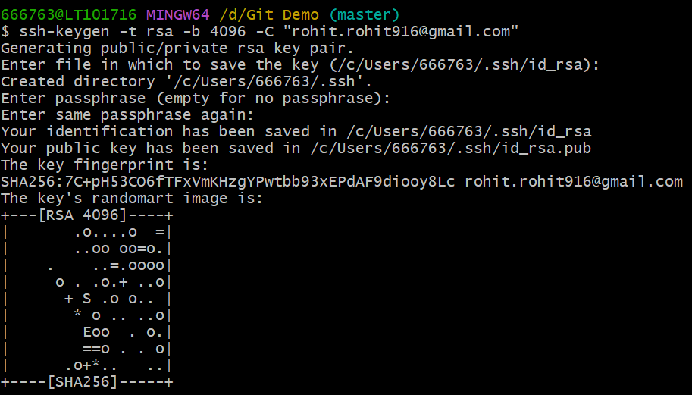

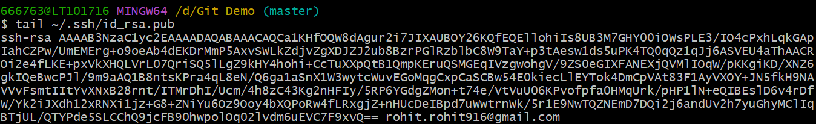



Linking GIT Local to Remote Repo –

Example: git remote add origin [git@github.com:Roheat94/Git-Training.git](mailto:git@github.com:Roheat94/Git-Training.git)

Git remote add origin <url/ssh>

git remote add remote-name remote-repository-location (LINKS LOCAL AND REMOTE)  
git push -u remote-name branch-name (SEND CHANGES TO REMOTE FROM LOCAL)

git push remote-name branch-name (SEND CHANGES TO REMOTE FROM LOCAL)

git pull remote-name branch-name (RECEIVES CHANGES FROM REPO)

**git push origin master** (Sends changes from local to remote repo)

**git pull origin master** (Sends changes from Remote repo to Local repo)

**ANSIBLE –**

Ansible is an open source engine that automates deployment and is a configuration management tool. It uses playbook to describe the jobs where the codes are written and uses YAML scripting. The tool is agentless and works by connecting nodes via SSH. It uses PUSH mechanism as deployment.

Ansible server - The machine where ansible is installed and from which all the tasks from playbook will be ran.

Module – Command set to be executed.

Inventory – File containing data about the NODES

Play – Execution of playbook is called as play.

Playbook – Code written in YAML format inside the playbook, which describes the task or infrastructure.

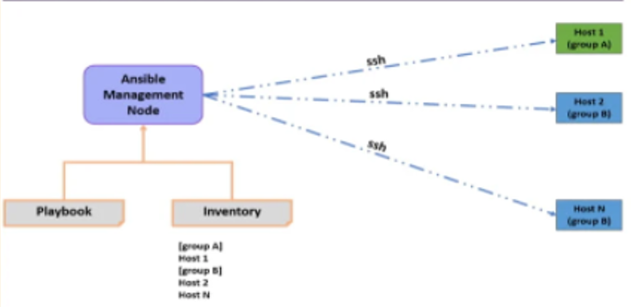

**Setting up an Ansible server** –

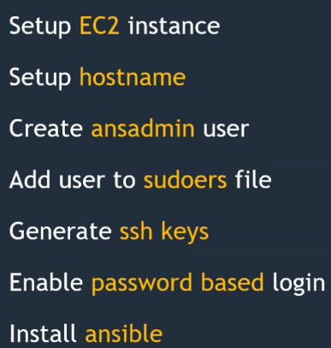

Ansible servers/hosts needs to be created inside the AWS platform by creating an EC2 (Elastic compute) engine selecting Linux machines. After the engines are created, login to the servers with their public IP’s via putty. Make sure SSH, keys are generated for authentication prior to login.

**Commands in Linux** –

Login as ec2-user  
Becoming Root user from ec2-user: Sudo su -

1. Downloading package: wget  
2. Installing package: sudo yum install <service name> -y (Ex: Installing Ansible, python, git etc.)

<amazon-linux-extras install ansible2> [For AWS linux]

In addition, to remove the package: sudo yum remove <service name> -y  
3. Create groups of the nodes inside the inventory: vi /etc/ansible/hosts (Provide the private IPv4 for config)   
Provide the [group name] and their [Private IP of the nodes]

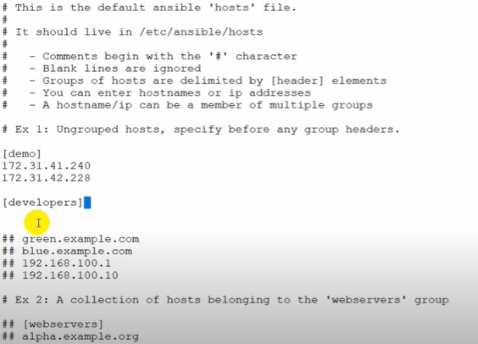

4. Save and quit: Esc>:wq  
5. Switch to insert mode: i  
6. Configure ansible nodes: vi /etc/ansible/ansible.cfg  
7. Uncommented: Remove # from the default values  
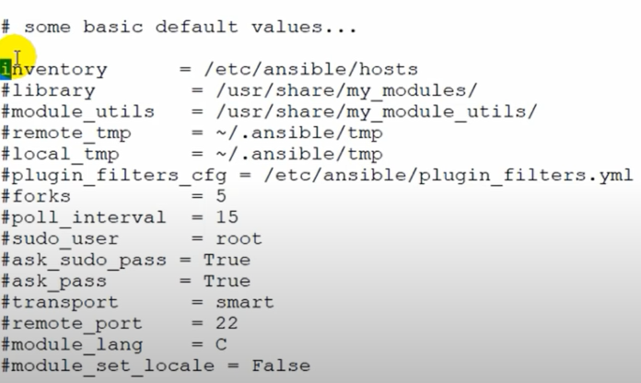

8. Adding new user/pwd for users: adduser <username>; passwd <username> Enter  
9: Becoming ansible user from root user: su – ansible  
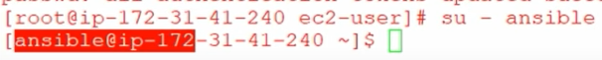

10. Clear command lines/screen: ctrl+L or clear  
11. Provide rights to ansible user as a root user: visudo  
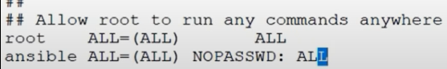  
12. Exit command: Exits and logout from current user to root user  
13. Create a new file: touch <file name1> <file name2>  
14. View the files created inside server/node: ls (LS)   
15. View hidden files created: ls –a (LS – A)  
16. To come out of ssh connection: cd..  
17. To remove or delete all the files from a server/node: rm –rf *

Establishing SSH connection between Ansible server to Nodes –

Make sure the public key is first configured for making SSH connection from main ansible server to nodes. If not, error – Permission denied

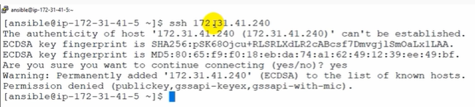

1. Go to root user

Command: vi /etc/ssh/sshd_config

Un comment the below values – Permit root login, Password Authentication

Follow the same steps in other nodes as well.

After the config changes has been made, make sure to perform a restart in the nodes as well as in the main ansible server to make the changes applied.

Command: service sshd restart

Now, make sure the all the components are in Ansible user value not a root user (su – ansible) [i.e.: ansible@ip]

Command: ssh <private ip of the node>  
Provide the password for the node for login as well

This will now establish a connection to the node from main ansible server.

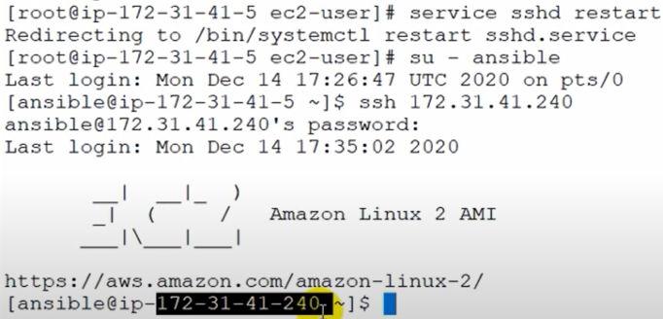

**Establishing Trust relationship between Ansible server and Node** –

This is usually done to avoid entering password every time you make a SSH connection from Ansible server to any other node.

Steps –

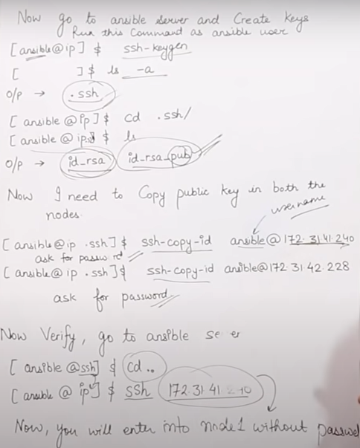

1. Remain in Ansible user value   
2. Enter command: ssh-keygen  
3. After the key has been generated, view it by entering: ls- a (the key will be in .ssh format)

4. Enter command: cd .ssh/ (You will now see that ansible@ip .ssh format is established)   
5. Type command “ls” to view the public and private key generated  
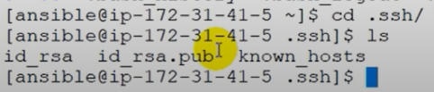

Id_rsa: Private key and id_rsa.pub: Public key

Now copy the SSH keys into both the nodes created: <ssh-copy-id ansible@node ip address>

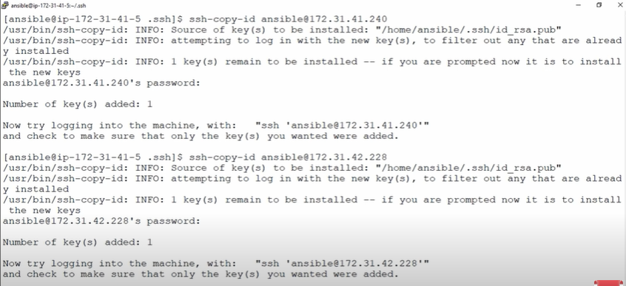

**Creating Groups of nodes/Host pattern inside the inventory**

1. To view all the groups/nodes/hosts inside the ansible server: ansible all - - lists-hosts (This will show the IP addresses of the nodes

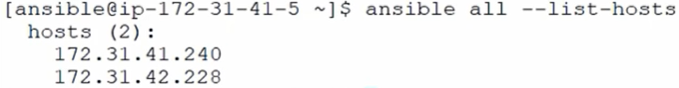

2. To view the details of the groups created: ansible <group name> - - lists-hosts

3. To view a particular node detail: ansible <group name> [0] - - lists-hosts (This will show the details of the 1st node only)

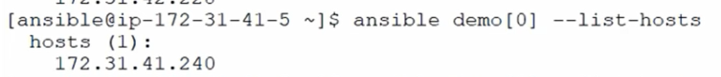  
Ex –

[0] – 1st node   
[1] – 2nd node   
[2] – 3rd node  
[x:y] – Details of those two nodes only inside the same group  
[2:4] – Details of 3rd and 5th node only of that group  
[-1] – Details of the last node

4. To view the details of different groups and their different node details:

ansible <group name> [x:y] :<group name> [x:y] - - lists-hosts

**Ad hoc Commands/Modules/Playbooks** –

Ad hoc commands are the set of commands, which are executed individually to perform quick functions. These are not used as a configuration management or deployment, because these are one-time performed commands.

**Idempotency**:  Idempotency is the property of certain operations that they can be applied multiple times without changing the results. It is any function can be executed several times without changing the final result beyond its first iteration.

NOTE: There is no idempotency in ad hoc commands; hence, it will keep over-riding the commands, which are already executed. However, Idempotency is present in Module & Playbook, so it will warn if a same/duplicate command is executed repeatedly.

MODULE: One command/ single set of work

PLAYBOOK: More than 1 module/ Multiple set of works or commands

Ad hoc commands –

1. To view all the files inside a group of the ansible server: ansible <group name> -a “ls” (-a stands for argument given before double quote always)   
2. To view all the files inside the ansible server: ansible all –a “ls”

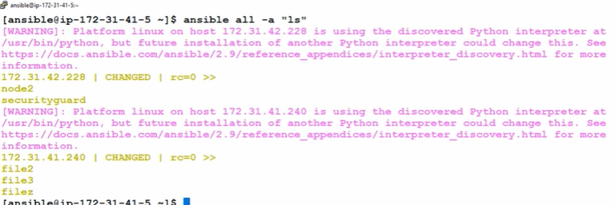

3. To create a file on all the nodes inside the ansible server: ansible all –a “touch <filename>”

4. Installing a package inside all the nodes of a group: ansible <group name> –a “sudo yum install httpd -y”   
5. Removing a package from the nodes of a group: ansible <group name> - a “sudo yum remove httpd –y”

Instead of SUDO, you can mentioned –ba (B stands for become)

MODULES – (-m command)

Modules are stored in the default location inside the hosts: /etc/ansible/hosts

1. Command related to installing/deleting/updating

Example: Installing a package inside all the nodes of a group: ansible <group name> -b -m yum –a “pkg = httpd state=present”

If Installing – PRESENT, Removing – ABSENT, Upgrading – LATEST

2. Command related to service (Start/stop)

Example: Starting “httpd” service inside all the nodes of a group: ansible <group name> -b –m service –a “name = httpd state = started”

3. Creating a user inside the nodes of a group: ansible <group name> -b –m user –a “name=XYZ”

4. Copy pasting files from ansible server to group: ansible<group name> -b –m copy –a “src=X dest=/tmp”

5. To check the copied file in the destination: ls /tmp/

5. Checking the status of any service: sudo service <service name> status

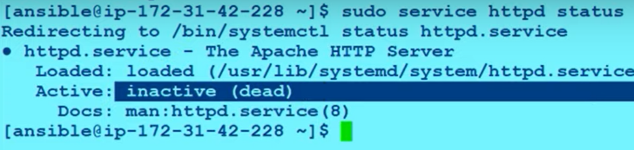

6. Checking the current configuration of any node in a group: ansible <group name> – m setup

PLAYBOOKS (YAML)

Playbooks are the files where Ansible code is written in YAML format. YAML stands for Yet Another Markup Language. Playbooks are one of the core features of Ansible and tell Ansible what to execute. They are like a to-do list for Ansible that contains a list of tasks.

YAML extension file always ends with .yml

Command to created playbook: vi <file name>.yml

After the Playbook file is created, VI editor will open and you need to define the set of values by pressing “I” (insert) key.  
Note: Always start with “- - -“ before defining (Three hyphen)

Hosts/user/become/connection/gather_facts.

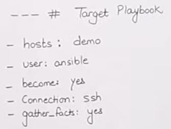 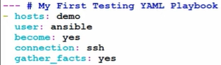

Command to execute a Playbook: ansible-playbook <file name>.yml

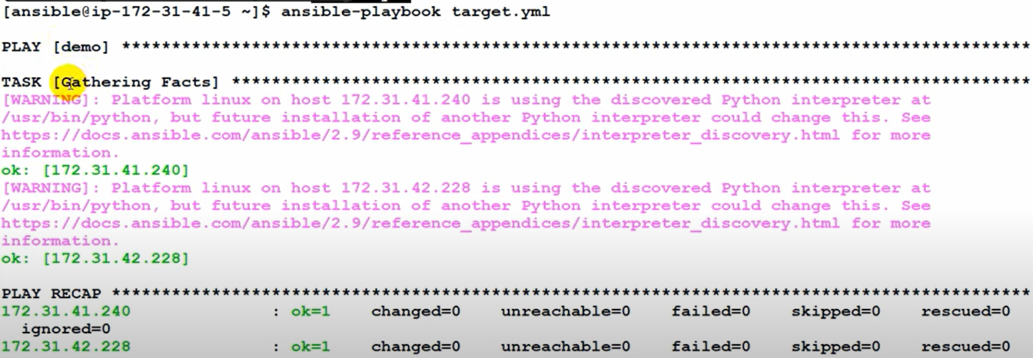

**Creating a Task inside the playbook** –

1. Create a playbook task file: vi <task file name>.yml 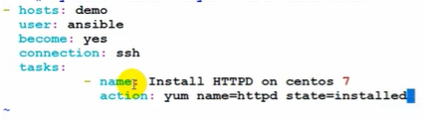

Escape: wq >enter.  
Now execute the playbook using ansible-playbook <task file name>.yml

**Creating a Variable inside the playbook** –

1. Create a playbook variable file inside the ansible server: vi <variable file name>.yml

Provide the details inside the editor as below:

Vars:  
 pkgname: httpd  
Tasks:  
 - name: install httpd server  
 action: yum name=’{{pkg name}}’ state= installed

Escape: wq >enter.  
Now execute the playbook using ansible-playbook <task file name>.yml

HANDLERS –

In Ansible, handlers are typically used to start, reload, restart, and stop services.

Handlers are just like regular tasks in an Ansible playbook (see Tasks) but are only run if the Task contains a Notify keyword and indicates that it changed something.

Tasks:  
 - name: Install httpd server  
 action: yum name=httpd state=installed  
 notify: restart httpd  
Handlers:  
 - name: restart httpd server  
 action: service name=httpd state=restarted

Escape: wq >enter.  
Now execute the playbook using ansible-playbook <task file name>.yml

DRY RUN –

Dry run in Ansible is to check whether the format of the playbook is written correctly or not

ansible-playbook <playbook file name>.yml - -check

Creating Encrypted Playbooks/VAULTS –

-Command: ansible-vault create <file name>.yml (This will create a playbook vault with password)

-Command for editing the vault playbook: ansible-vault edit <file name>.yml

-Command to change the password of the vault: ansible-vault rekey <file name>.yml

-Command to encrypt an existing playbook: ansible-vault encrypt <file name>.yml

-Command to decrypt an existing playbook: ansible-vault decrypt <file name>.yml

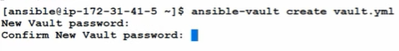

Executing an encrypted playbook file: ansible-playbook <file name.yml> -ask-vault-pass

ANSIBLE ROLES –

Ansible roles allow you to develop reusable automation components by grouping and encapsulating related automation artifacts, like **configuration files, templates, tasks, and handlers**.

Command for creating a directory: mkdir –p playbook/roles/webserver/tasks (-P stands for parent directory)

Lab steps –

1. Create a tree: sudo yum install tree –y  
2. Open tree command: tree

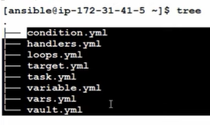  
3. Create a parent directory  
4. Check the directory by running tree command

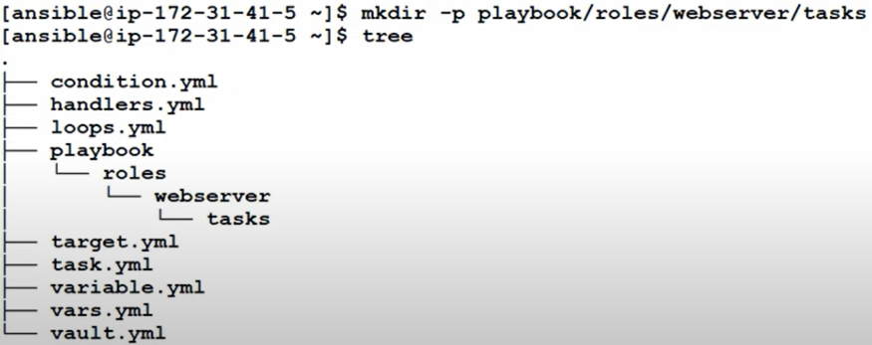

5. Go inside playbook: cd playbook/ (ansible@ip<>playbook)  
6. Check the directory with the tree command

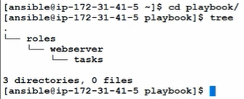

7. Create a “MAIN file” inside the task playbook: touch roles/webserver/tasks/main.yml  
8. Create a “MASTER FILE” in the playbook just equal to ROLES: touch <master>.yml

Now define all the tasks related to the playbook inside MAIN file and define the actions in the MASTER file.  
9. Execute the MASTER playbook: ansible-playbook <master>.yml

**DOCKER CONTAINER ANSIBLE (UBUNTU) –**

1. Run the container inside the docker: docker run –d <username>/ubuntu-ssh-enabled  
2. Identify the internal IP: docker inspect <container-id-name>  
3. Creating SSH connection: ssh <container-ip>

**Web Application Installation Instructions for Centos 7-**

1. **# Install Python Pip and dependencies on Centos 7:**

sudo yum install -y epel-release python python-pip

sudo pip install flask flask-mysql

2. **# Install MySQL Server on Centos 7**

wget http://repo.mysql.com/mysql-community-release-el7-5.noarch.rpm

sudo rpm -ivh mysql-community-release-el7-5.noarch.rpm

sudo yum update

sudo yum -y install mysql-server

sudo service mysql start

**ANSIBLE PLAYBOOK (Web Application Deployment)**

name: Deploy web application  
hosts: db_and_web_server  
tasks: [REQUIRED TASKS WITHOUT INSTALLATION COMMANDS]  
 -name: Install dependencies  
 -name: Install Mysql database  
 -name: start Mysql database  
 -name: Create application database  
 -name: Create application database user  
 -name: Install python flask dependencies  
 -name: copy web-server code  
 -name: run web-server

Example – Create an inventory and add 2 target server hosts into the inventory file for deploying the playbook.



a) **Tasks for installing dependencies (Python)**

name: Deploy web application  
hosts: db_and_web_server1, db_and_web_server2

tasks:

- name: Install required dependencies  
 apt: name= {{ item }} state=installed (apt=module name)  
 with_items:  
 - python  
 - python-setup tools  
 - python dev  
 - build essential  
 - python pip

b) **Tasks for installing MySQL DB**

tasks:

-name: Install MySQL database  
 -apt: name = {{item}} state=installed  
 with_items:

-mysql-server  
 -mysql-client

c) Tasks for restarting MySQL service

tasks:

-name: Restart Mysql service  
 service:   
 name: mysql  
 state: started  
 enabled: yes

D) Create Database and database users

**-** **name:** Create database user with name 'Rohit' and password '12345' with all database privileges

**community.mysql.mysql_user:**

**name:** Rohit

**password:** 12345

**priv:** '*.*:ALL'

**state:** present

E) Create a new Database in Mysql with username “Rohit”

**-** name**:** Create a new database with name “Rohit”

mysql_db**:**

name**:** bobdata

state**:** present

F) Copy application code file “app.py” to target server /opt/app.py (Using copy module)

- name: Copy application code file 'app.py' to target server

copy:

src: app.py

dest: /opt/app.py

**CI/CD Pipeline –**

A **CI**/**CD pipeline** is a series of steps that must be performed in order to deliver a new version of software.

There are four stages of a CI/CD pipeline **1) Source Stage, 2) Build Stage, 3) Test Stage, 4) Deploy Stage**

**JENKINS –**

jenkins@1994 (Jenkins pwd) username: admin

/var/lib/jenkins/secrets/initialAdminPassword (path)

Jenkins is an open source automation server. It helps automate the parts of software development related to building, testing, and deploying, facilitating continuous integration and continuous delivery. This is done with the help of plugins installed in Jenkins, which helps the progress of the pipeline job from one stage to another.

Jenkins infrastructure is based on MASTER and SLAVE where the work is distributed.

Build trigger types –

**Jenkins build periodically vs Poll SCM (CRON JOBS)**

Build periodically will build the job irrespective of any code change in the GitHub whereas in Poll SCM it will trigger the build whenever there is a code change in the GitHub repository.

***** stands for minutes (0-59), hours (0-24), day of month (1-31), month (0-12), day of the week (0-7)

If SLAVE nodes are not available then the jobs are by default processed by the Jenkins master.

**JENKINS MASTER SLAVE NODE CONFIGURATIONS** –

1. Jenkins server and Slave node  
2. Install java on slave node (Create EC2 engine naming Jenkins Slave)  
3. Configure slave node under manage nodes of Jenkins master  
4. Download agent.jar onto slave node  
5. Run java command to connect with Jenkins server

Steps –

Manage Jenkins> Manage Nodes > New Node> Give a node name> Select permanent agent> Provide description > Provide remote root directory .

Download the jar file created inside the Slave node and paste it in the Slave Server for establishing connections

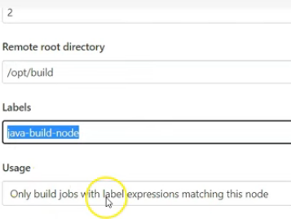

After successfully establishing the connection, Create a new build and select the job with option “**Restrict where this project can be run**” and mention the Slave label to run the build on the slave node.

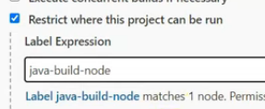

Scripted vs Declarative Pipeline –

Declarative pipelines always begin with the word pipeline. Scripted pipelines, on the other hand, always begin with the word node. Declarative pipelines break down stages into individual stages that can contain multiple steps. Scripted pipelines use Groovy code and references to the Jenkins pipeline DSL within the stage elements without the need for steps.

Declarative pipeline is a new feature that supports the pipeline and is more easier to read and write, whereas in Scripted pipeline it is much stricter groovy based syntax’s where the Jenkins file is written on the Jenkins UI instance.

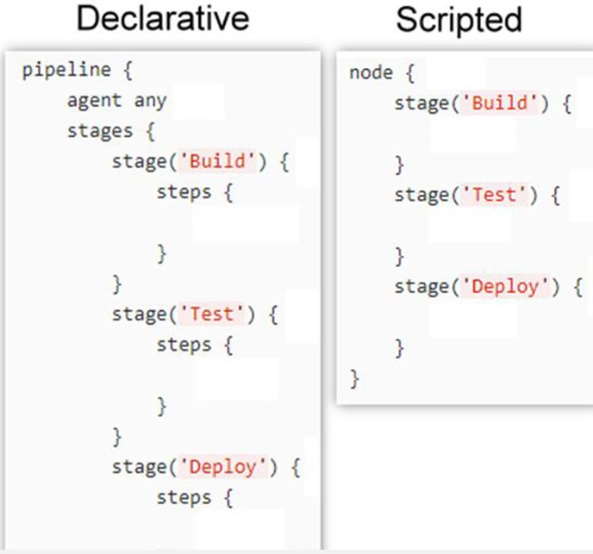

**JENKINS FILE** –

A Jenkins file is a text file that contains the definition of a Jenkins Pipeline and is checked into SCM (like Git). The Jenkins file is written using the **Groovy Domain-Specific Language**

Sample declarative pipeline script:

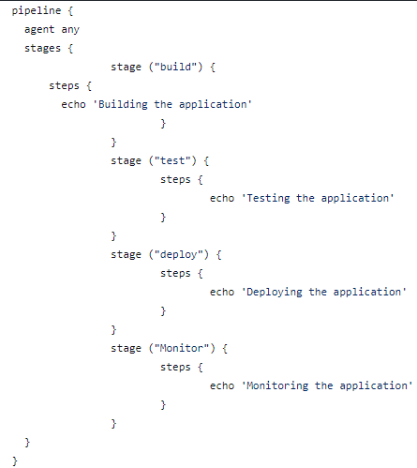

Post Conditions in a declarative pipeline –

post {  
 always { [This will always get executed irrespective of the build result]  
 // <Command>  
 }  
 success { [This will only get executed when the build is successful]  
 // <command>  
 }  
 Failure { [This will only get executed when the build fails]  
 // <command>  
 }

When Expression in a Declarative pipeline –

Stage (“Test”) {  
 when {   
 expression {  
 **BRANCH_NAME** == ‘dev’ || **BRANCH_NAME** == ‘master’  
 }  
 }  
steps { [This step will only get executed as per when expression]  
 echo ‘Testing the app’  
 }  
}

NOTE: **What variables are available from Jenkins** ? <URL> /env-vars.html

Building project through MAVEN –

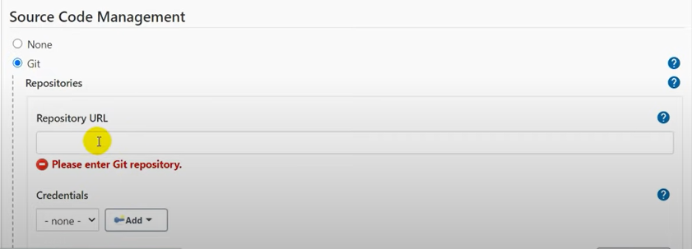

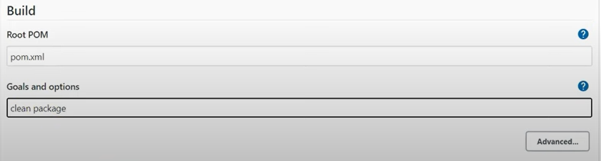

**Console Output**

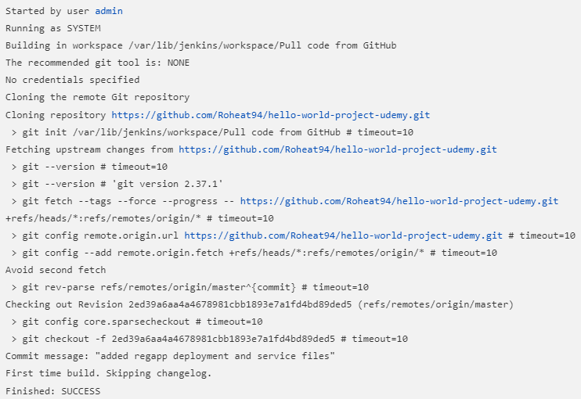

MAVEN –

Maven is a build automation tool used primarily for Java projects helping to download dependencies, which refers to the libraries or JAR files. It is based on POM (Project Object Model) Maven can build any projects into desired outputs in .jar/.war or metadata. It is written in JAVA.

Main configuration file is – pom.xml

POM refers to all the details of the file that contains dependencies of the projects and their configuration

Local Repository –It refers to the repository present in the local machine of the developer where all the project material is saved.

Remote Repository –It refers to the repository present in the web server which is used when MAVEN requires dependencies

Central Repository –It refers to the MAVEN community where the dependencies are present which cannot found in the local repositories

**FREESTYLE DEVOPS PROJECT**

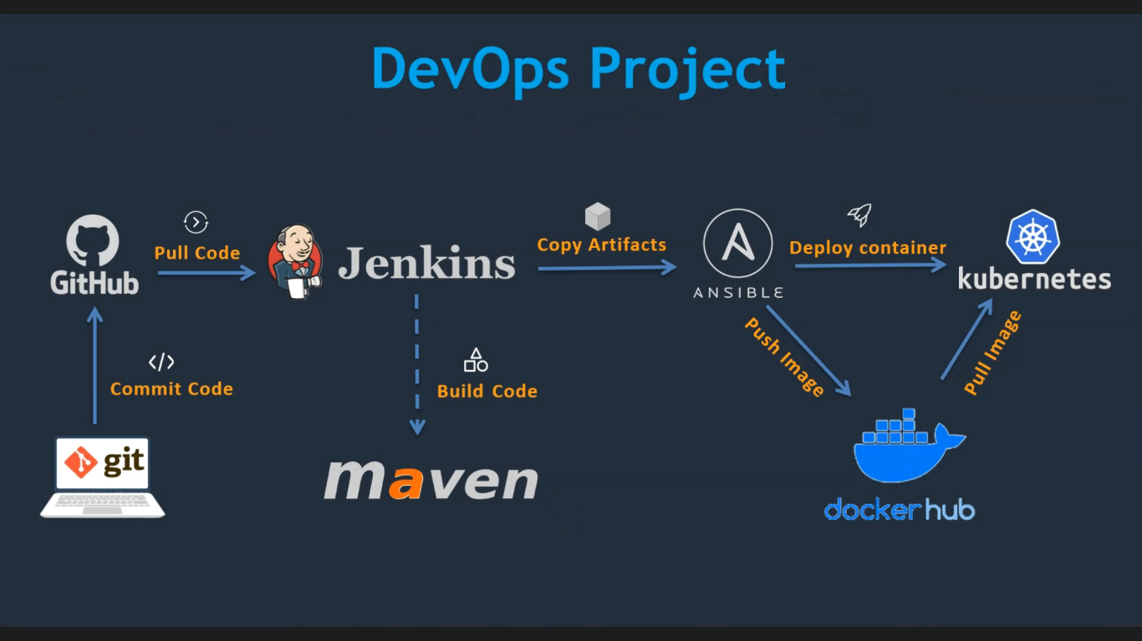

STEPS OF COMPLETE DEVOPS PROJECT –

1. Developers will have their source code in their local environment

2. The Developers will then commit their code to GitHub repos

3. Once the code is available in GitHub, Configuration Integration tool Jenkins will pull the code from GitHub via SSH/URL to create jobs and build the artifacts with the help of Maven.

4. Once the artifacts are generated in WAR, JAR format it will be copied onto Ansible

5. Ansible is going to make it a containerized application by creating an image and is going to deploy the code on Kubernetes

**JAVA and JENKINS** – (8080)

Create an EC2 linux instance and name it Jenkins server. Inside the server download java and Jenkins and install them and access it on the webUI from port 8080.

The builds will be in format of WAR, JAR files inside the Jenkins server. (Var/lib/jenkins/workspace/target)

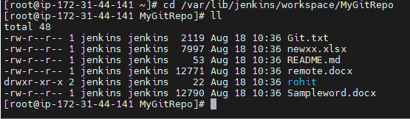

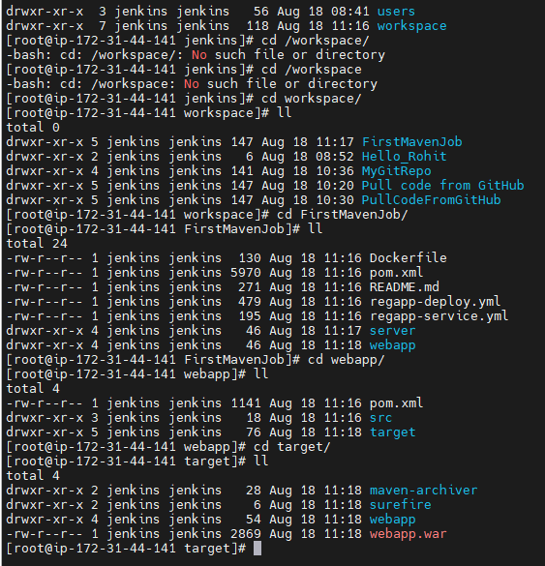

Also install the plugin **MAVEN** (Build tool) and **GIT** (SCM) from Jenkins UI (Manage Jenkins > Install plugins)

**APACHE TOMCAT** –

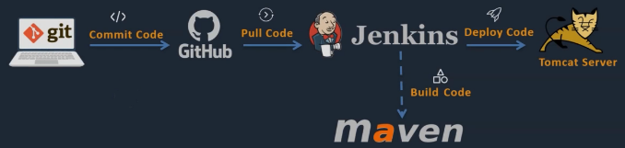

Setting up a Tomcat server: Create an EC2 linux instance in AWS/GCP > Install java in that server (amazon-linux-extras>amazon-linux-extras install java-jdk11) > Configure Tomcat (wget Tomcat download URL) > Start tomcat server (./startup.sh)> Access the web UI from port 8080 (Public ip address of the instance: 8080)

Tomcat download path: wget < <https://downloads.apache.org/tomcat/tomcat-9/v9.0.65/bin/apache-tomcat-9.0.65.tar.gz.asc>>

Then extract it: tar –xvzf <downloaded file> (This is use to extract tar.gz files)

After extracting, you will see a file application file downloaded successfully (Apache-tomcat-version). Rename it to **Tomcat** (mv <file name> <renamed file>) to avoid confusion and give a restart in the bin directory (cd/opt/bin/.startup.sh)

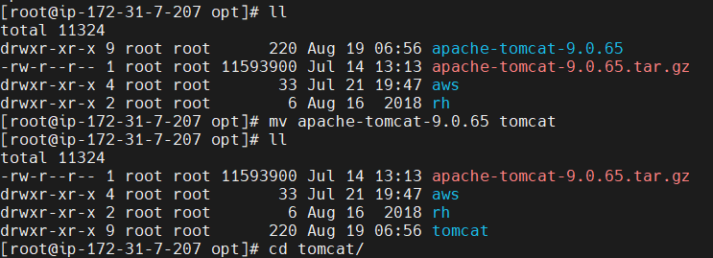

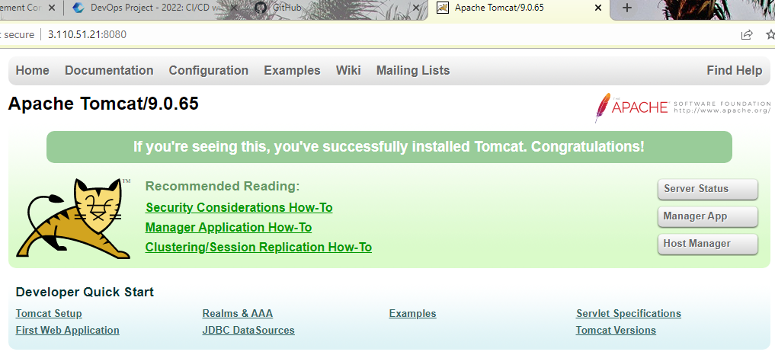

Now on clicking on the Manger app it will throw a **403 access denied error**, Hence we need to update the context.xml inside the tomcat server to grant permission to use tomcat outside the server (directly on web)

Steps : Go to tomcat directory inside the server (cd /opt > cd tomcat/> ll) ; Then use find command to search context.xml file. (find –name context.xml)

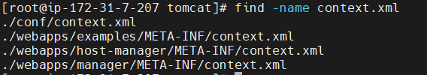

Now edit the 2 webapp context.xml file by opening vi editor (**Example**: vi ./webapps/host-manager/META-INF/context.xml)

Comment out the section, which allows tomcat to use from local host only (<! - - to comment out - ->)

BEFORE –

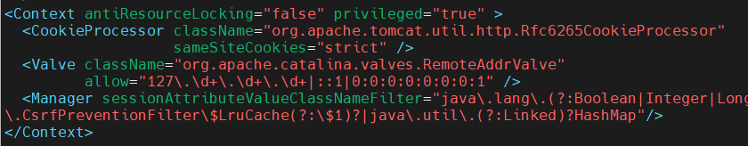

AFTER –



After making the changes, make sure to shut down and restart tomcat services (cd bin/> ll > ./shutdown.sh> ./startup.sh)

Now we will be able to access Tomcat services from URL (After reloading it should ask for credentials)

Now for getting credentials we need to configure the conf file inside tomcat directory and update tomcat-users.xml

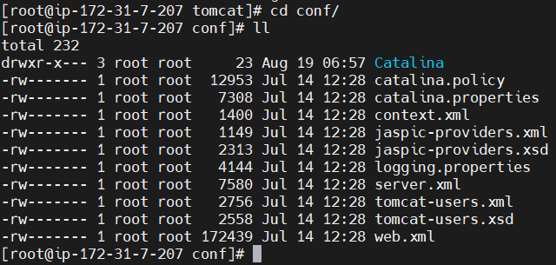

Open the vi editor and add the user profiles inside <tomcat-users.xml> (vi tomcat-users.xml).

Add profiles inside the editor –

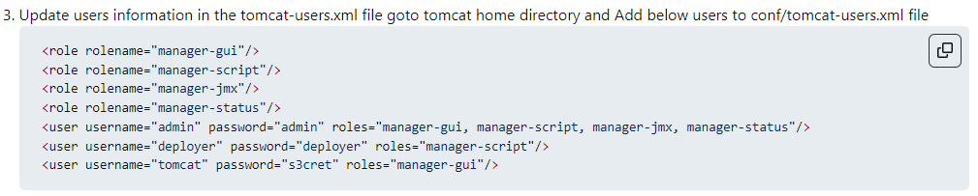

Link - <https://github.com/Roheat94/Simple-DevOps-Project/blob/master/Tomcat/tomcat_installation.MD>

Restart the tomcat services to take effect in the changes (Shutdown.ssh, startup.ssh).

Now refresh the Tomcat webUI and enter the credentials as mentioned (usr: tomcat | pwd: s3cret)

It will now load the Tomcat web application manager

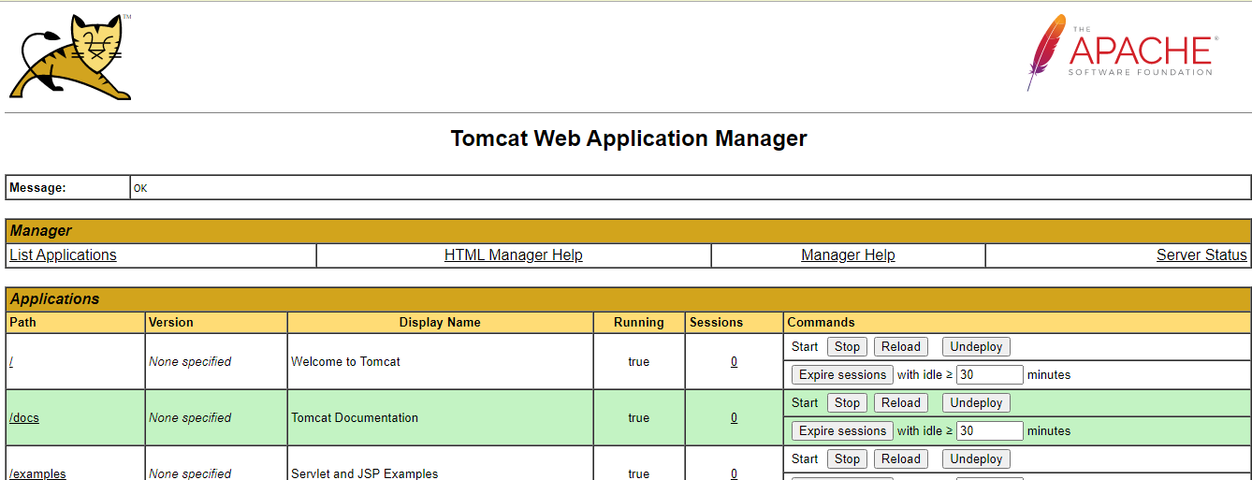

Now we can host our application on this tomcat server. We can now build and deploy the Jenkins job to this tomcat server using plugins.

The artifacts built on Jenkins with help of Maven, will be deployed to a Tomcat apache server which will have Jenkins already installed and configured. (Build and deploy to a target server)

The required plugin for integrating tomcat with Jenkins – Deploy to container

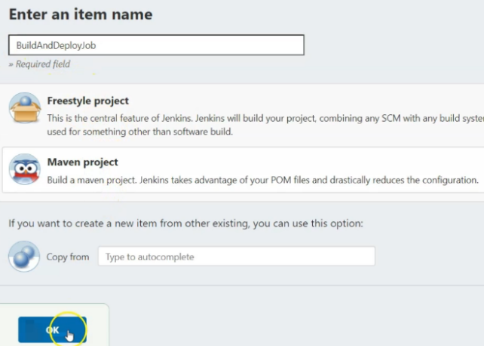

After TOMCAT apache has been installed and configured in the Jenkins server, UI, Create a job and select the post build actions as “Deploy war/ear to a container”, and containers sections will have the details of the Tomcat URL (where it will deploy the artifact)

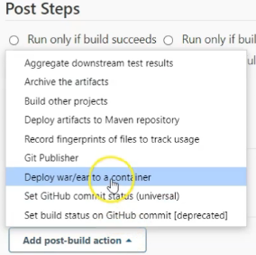 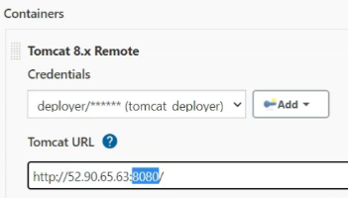

**Deploying the code to Docker Container** –

A) Create an EC2 linux instance in AWS/GCP and install Docker inside it: (Name it as Docker host)

1. yum install docker –y  
2. Service docker start  
3. Service docker status  
4. Docker ps (tells how many containers are currently running)   
5. Docker ps –a (tells total number of containers inside the docker host)

B) Create a docker container: (with Tomcat image)

1. To create a docker container, we need a docker image (docker run command)  
2. Directly you can pull a docker image from docker hub portal (Ex: pull tomcat image)   
3. Command to pull an image from docker hub – docker pull <tomcat>  
4. To check the image created – docker images

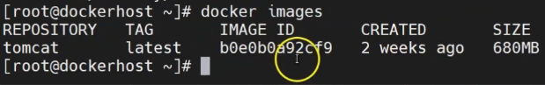  
5. Now, create a container inside the docker using tomcat image: docker run - d - -name tomcat-container –p 8081:8080 tomcat (-d is detached mode and –p refers to port number where tomcat is running) 8081 is for exposing externally.



To login inside a docker container: docker exec –it <container id> /bin/bash

-v: For volume, if container crashes data will be saved.

How to create a Docker file manually –

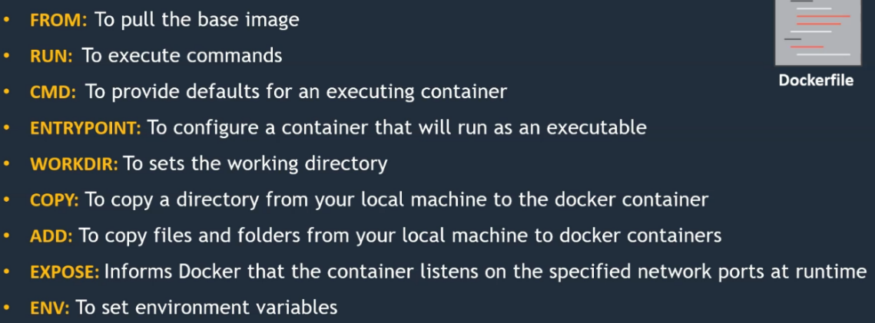

**CMD vs ENTRYPOINT**

The CMD and ENTRYPOINT commands are almost similar to each other however, CMD commands can be overwritten but ENTRYPOINT commands cannot be overwritten.

Open a file: vi <Docker file> and then execute the below commands

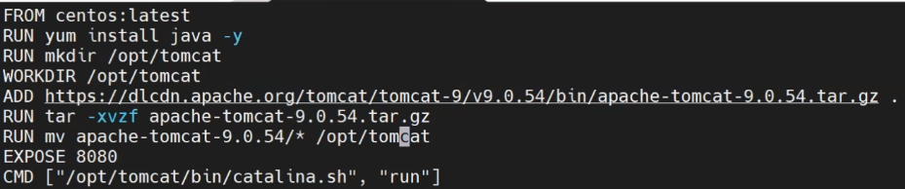

After the commands have saved and applied run the docker build command to execute the docker file.

Command: docker run –t <image name> or docker build –t <image name> (To create a docker build)   
and then create the Tomcat container after the docker file image of Tomcat is executed:

Docker run –d - - name mytomcat server –p port 8087:8080 mytomcat (It is exposed externally on port 8087 and 8080 internally)

8087 is exposed in real time.

**Creating a customized Docker file for TOMCAT** –

**FROM** tomcat:latest  
**RUN** cp –R /usr/local/tomcat/webapps.dist/* /usr/local/tomcat/webapps (Copy the context inside the webapp.dist file to webapps)

Then use the DOCKER BUILD command to create an image out of it (docker build –t <image name>)

Then create a container out of the same image: docker run –d - -name <container name> -p <port range> <image name>

C) **Integrate Docker with Jenkins**

1. Create a docker admin user in the docker host (useradd dockeradmin)   
setup a password: passwd <pwd> (usrname and pwd both **dockeradmin**)

Add this <Dockeradmin> user to Docker group (Command: usermod –aG docker <dockeradmin>)

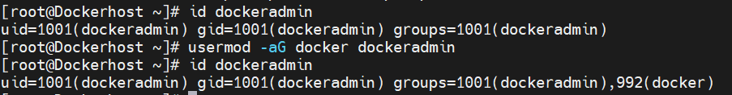  
2. Copy all the artifacts from Jenkins to docker host (Publish over SSH plugin)

Manage Jenkins > configure sys > ssh servers > add server > provide the details of the dockeradmin

Go to advanced settings and provide the dockeradmin password (use pwd based authentication) and the test connection. Apply and save the configurations.

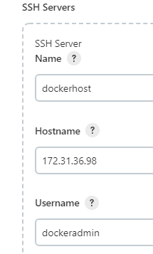

3. Configure the docker host in the Jenkins web UI (Go to manage Jenkins> configure systems)

4. Configure the details of the docker instance with private IP address of the EC2 instance in SSH server field  
5. Now create a jenkins job and mention the post build actions as “**Send build artifacts over SSH**”  
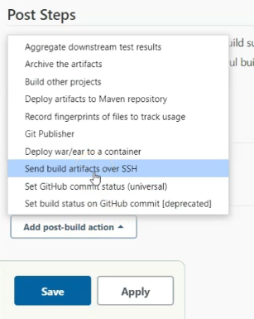

D) Automate the build and deployment on Docker container end to end (It will auto copy the artifacts to docker host, create a docker image and container out of it)

1. Go to configure settings of any job and specify the docker commands to create a docker image and docker container (docker build –t/docker run –d) in the “**Exec command**” section

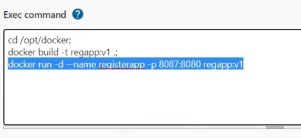

**Integrating ANSIBLE into CI/CD Pipeline** –

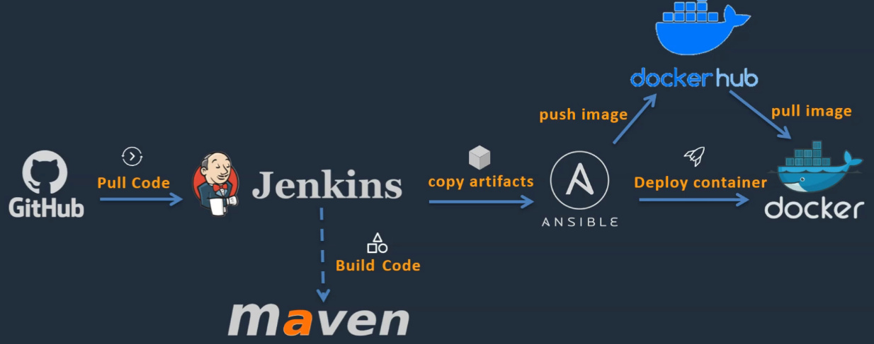

Here Jenkins is going to get the code from GitHub, build and copy those artifacts to an Ansible server.

It is now Ansible job to create images and deploy the containers. These images will be pushed to Docker Hub (Cloud repo) and whenever we will execute a playbook to deploy container, the docker host will communicate with docker hub, will pull the image, and will create an application docker container.

**Setup** –



NOTE: ANSADMIN user is to be created on both Ansible and Docker Host server separately

Setting up Ansible steps with commands:

To change the hostname: vi/etc/hostname (Delete and rename it to ansible server and save, restart)   
init 6 (To reboot)  
Create ansible admin user: <useradd ansadmin>; passwd <pwd>  
Give sudo privileges to ansadmin user: visudo

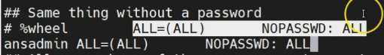  
Enable password-based authentication: vi/etc/ssh/sshd_connfig; /password; Enable by un-commenting password authentication and save.

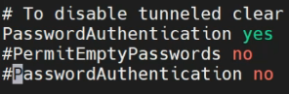 **service sshd reload** (To make the changes come into effect)

Create ssh keys for ansadmin user: ssh-keygen  
Install ansible: sudo yum install ansible (To check the version installed “ansible - - version”)

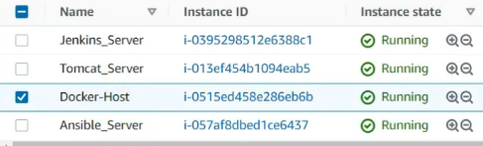

**Integrate Docker with Ansible** –

A) Create a playbook that is going to communicate with Docker host to create a container

1. Create an “ansadmin” user account on docker host > add ansadmin to sudoers file > Enable pwd based login  
2. Configure the docker host EC2 instance created earlier (Login to docker host)   
3. Create ansadmin user: useradd ansadmin (create pwd as well)   
4. Give sudo privileges to the ansadmin user (visudo)

B) Create a Docker host in Ansible server as a managed node in the inventory

1. Command: vi /etc/ansible/hosts (Provide the private IP address of the docker host server and save the file) in the editor <:wq>  
2. Copy the ssh keys to target server (ansible server to docker host): cd .ssh [id_rsa is the private key; id_rsa.pub is the public key. (For this 1st login as ansadmin user from a root user) [sudo –su ansadmin]  
3. Command to copy the SSH keys to docker host server from ansible server: ssh-copy-id <private ip of docker host server>

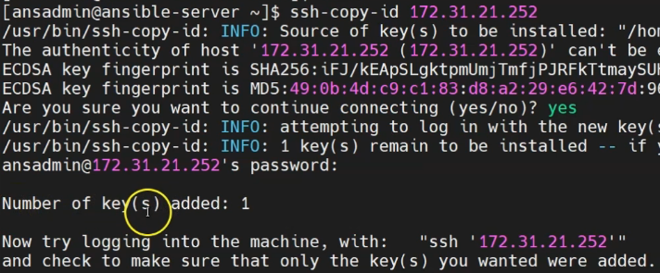

C) Integrate Ansible with Jenkins –

1. Go to manage Jenkins section > Configure system > Publish over SSH > Provide the details of the ansible server

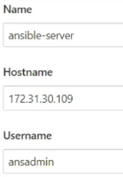

2. Provide the password-based authentication of the ansadmin user and save the configuration.  
3. Now, create a new Jenkins job where it will build and copy the artifacts to the ansible server  
4. While building the job in the “**post build action**” select the ANSIBLE SERVER instead of docker host for sending build artifacts over SSH  
5. Goals and options: Clean install

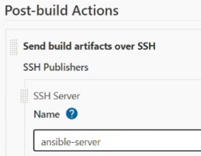  
6. Command for changing ownership of any file/directory from root user to local user:

Sudo chown user: user <directory name>

D) Build an image and create container on Ansible –  
1. Now, we have to build a docker image and create a container out of it on the ansible server.  
Install docker in the ansible server: sudo yum install <docker> -y

2. Now add the ansadmin user into the docker group (Then only we can use docker commands as ansadmin): sudo usermod aG docker ansadmin  
To check : <id ansadmin> which group it belongs to   
3. Now check the status of the docker and start the services: service docker status / sudo service docker start

E) Ansible playbook to create docker image and container –

Sample playbook file written in ansible server

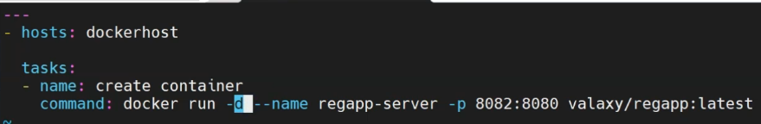

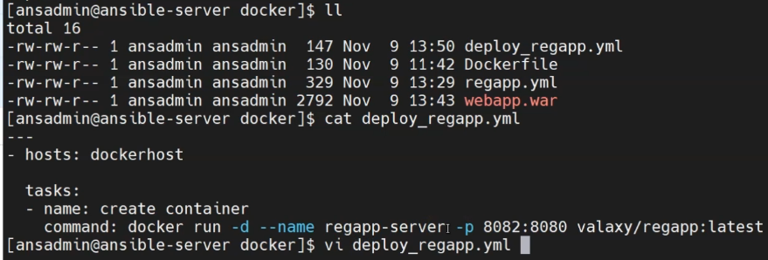

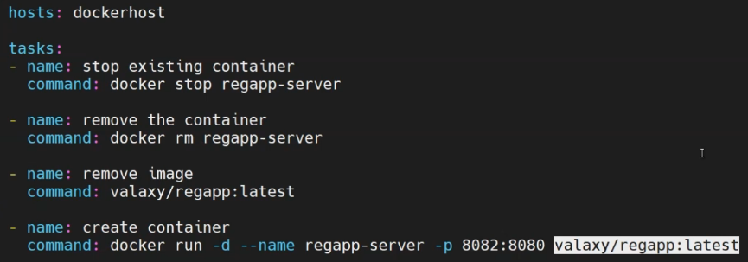

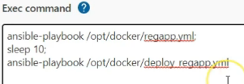

Ansible command is mentioned to execute the playbook for creating a docker image and deploying it on the docker host inside Jenkins job.

Once the Jenkins job is built, we can see the docker images and container created inside the docker host server and access the tomcat webapp on port created (mostly 8080 range).

**KUBERNETES FOR DEPLOYMENT OF CONTAINERS** –

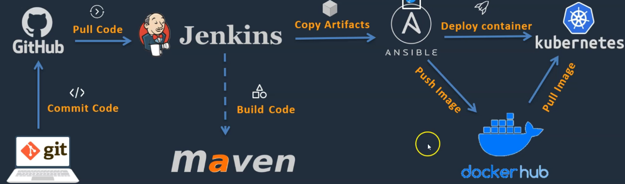

Deployment of applications are done in containerized pods in order to keep the application stable in case any docker container goes down, pods will keep the application running all the time.

**Setting up of Kubernetes environment on AWS (EKS)–**

1. Go to AWS management console > Search for services > EKS (Elastic kubernetes service)> Add cluster > Create > Configure the cluster

OR

Configure an EC2 instance and setup the EKS cluster with the bootstrap image

NOTE: Install kubectl, eksctl and provide IAM permissions

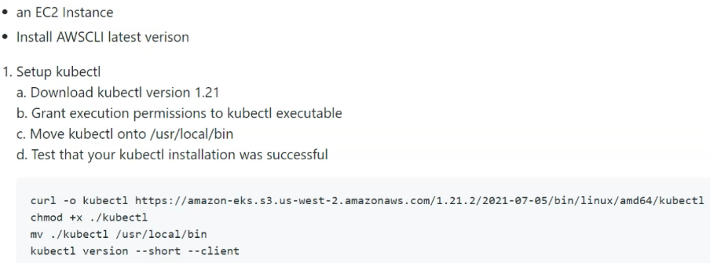

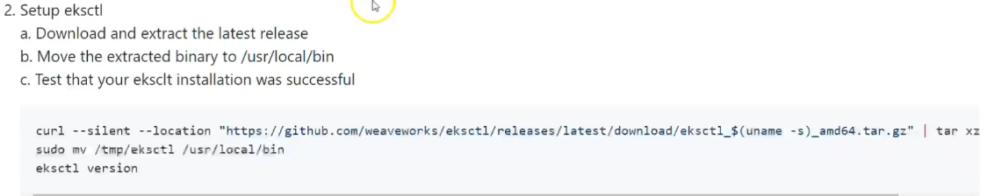

Installation command for kubectl version 1.21: (Linux)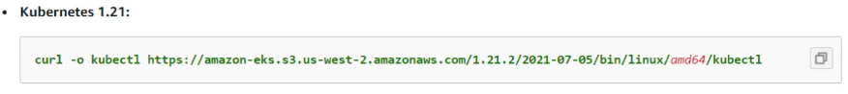

A) Create a bootstrap image to create EKS cluster –

1. Create an EC2 instance with below configurations: Amazon Linux machine 64bit(x86)  
2. Choose T2 micro instance type (free tier eligibility)   
3. Add tags and name the EKS cluster  
4. Configure the security group  
5. Launch instance

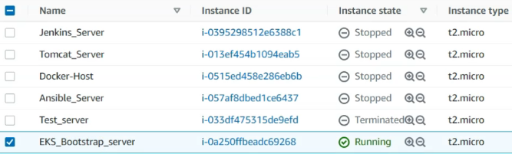

B) Install the latest version of EKS CLI

$ curl "https://awscli.amazonaws.com/awscli-exe-linux-x86_64.zip" -o "awscliv2.zip"  
unzip awscliv2.zip  
sudo ./aws/install  
aws - -version

C) Install KUBECTL version 1.22

**curl -o kubectl https://s3.us-west-2.amazonaws.com/amazon-eks/1.22.6/2022-03-09/bin/linux/amd64/kubectl**

D) Apply execute permissions to KUBECTL

Command: **chmod +x ./kubectl  
mv kubetcl /usr/local/bin**

E) Install EKSCTL

**curl --silent --location "https://github.com/weaveworks/eksctl/releases/latest/download/eksctl_$(uname -s)_amd64.tar.gz" | tar xz -C /tmp**

**sudo mv /tmp/eksctl /usr/local/bin**

F) Provide IAM roles (Identity access management)

Go to IAM page in AWS console> Roles> Create Role> Select EC2 > Search for policy: Amazon EC2Full access, Cloud formation full access, IAM Full access > Enter a Role name > Create role> Add it to the EC2 instance created for EKS server bootstrap (Actions>Security>Modify IAM role>Select role)

G) Create EKS Cluster

eksctl create cluster \

--name my-cluster \

--version 1.22 \

--without-nodegroup

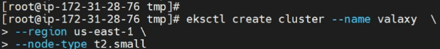

eksctl create cluster --name cluster-name \

--region region-name \

--node-type instance-type \

--nodes-min 2 \

--nodes-max 2 \

--zones <AZ-1>,<AZ-2>

**Example:**

eksctl create cluster --name valaxy-cluster \

--region ap-south-1 \

--node-type t2.small \

**Integrating Kubernetes in CI/CD pipeline** –

A) Writing a deployment definition file:

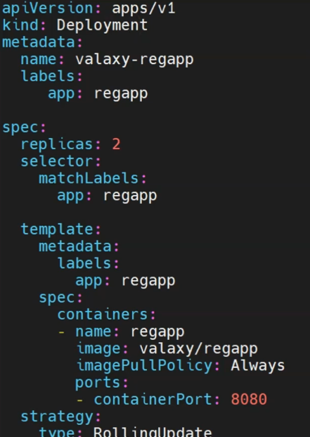

Strategy:  
 type: RollingUpdate  
 rollingupdate:   
 maxSurge: 1  
 maxUnavailable: 1

B) Write a service definition file:

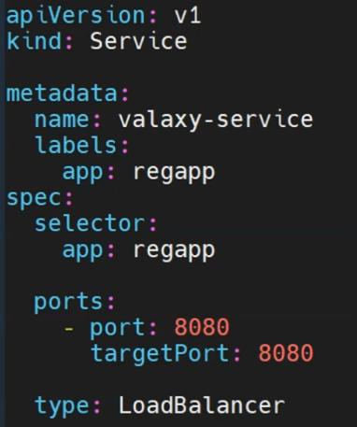

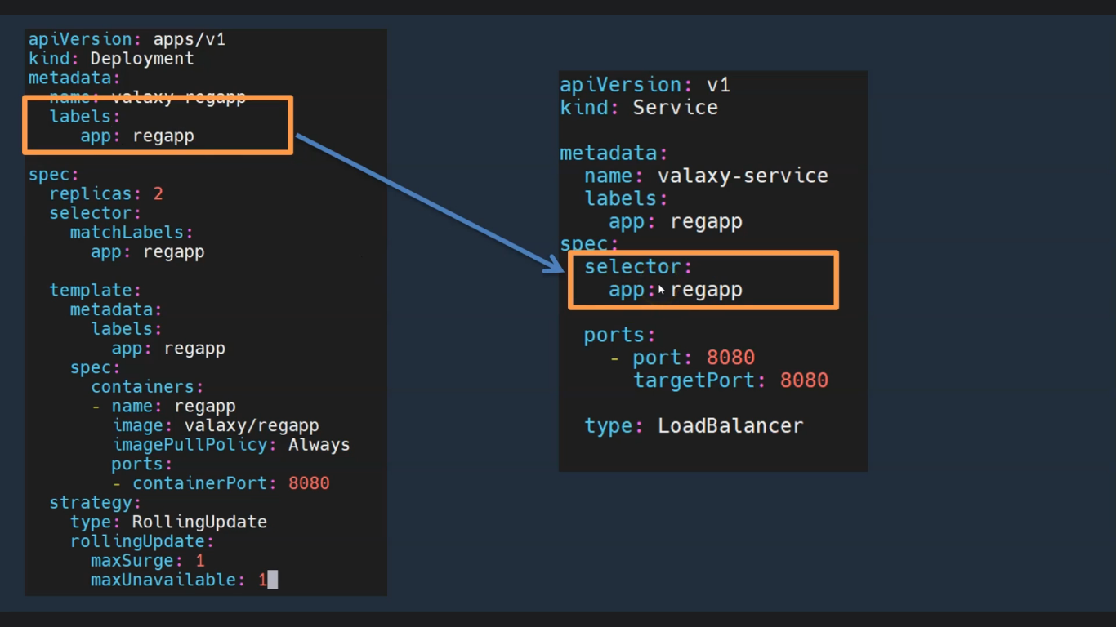

**Integrate Kubernetes cluster with Ansible** –

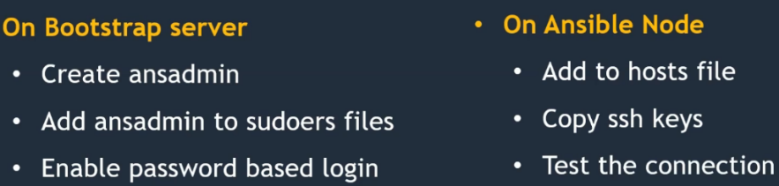

A) On Kubernetes cluster bootstrap server:

1. Create an **ansadmin** user and **password** on the EKS bootstrap server.

useradd ansadmin > passwd ansadmin > visudo > allow root to run any commands anywhere > add ansadmin >Next enable password based authentication >command (vi/etc/ssh/sshd_config) > uncomment the password authentication Yes and comment out the NO > service sshd reload

B) On Ansible server:

Switch from the root user to ansadmin user (sudo –su ansadmin) >Create a host named [Kubernetes] and add the IP-address (vi/etc/ansible/hosts) or (vi host); as well as create a group named [Ansible server] (provide IP address as well) and a local host.

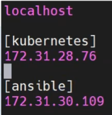

After creating the hosts, copy the ssh keys > ssh-copy-id <Kubernetes ip>

C) Create Ansible playbooks for Deploy and Service files:

1. On the Ansible server (ansadmin user), create a playbook named “vi kube_deploy.yml” we are going to execute these playbooks on the kubernetes (EKS cluster)

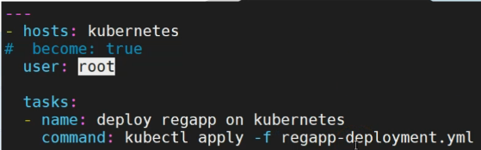

2. Create another playbook named “vi kube_service.yml” and write the playbook

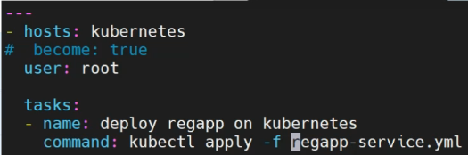

D) Create a Jenkins deployment job for Kubernetes:

1. Deploy as Pod

Go to Jenkins webpage and create a new item named “**Deploy_on_Kubernetes**” using freestyle project > “**Send build artifacts over SSH**” in post build actions > Choose SSH server as “**ansible server**” > In exec command section write the ansible playbook commands.

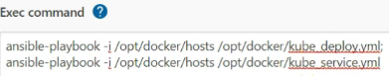

**AWS DEVOPS –**

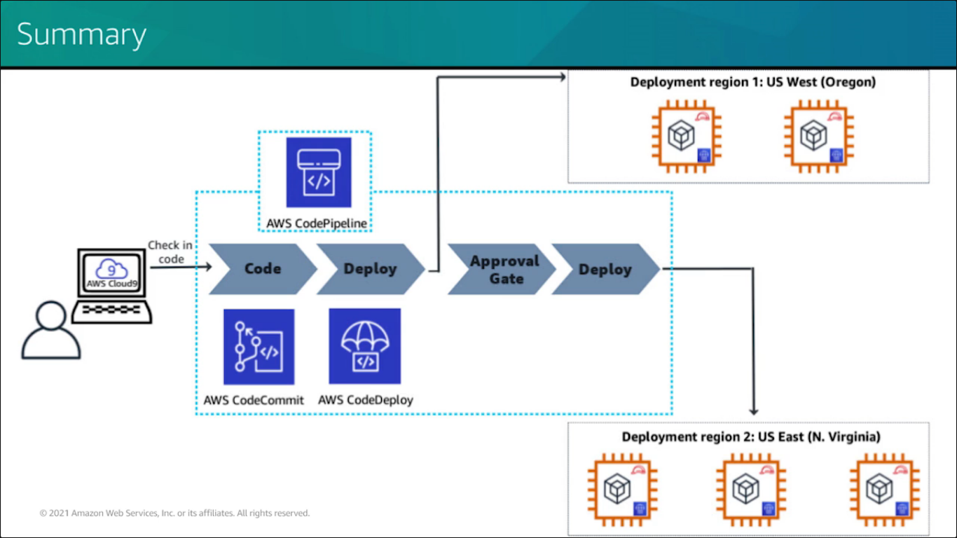

**Monitoring services in AWS** – Grafana, Cloud trail, Cloud watch, Prometheus

**Container Services in AWS** – ECS, EKS

**Storage services in AWS** – S3, Glacier, EFS

AWS Lambda – Just runs the code and provides the output (API, JSON)  
AWS Beanstalk – Hosts your webapp and provides the health check  
EC2 – Infrastructure as service (IaaS) launches a VM in any OS as u want  
S3 (Simple storage service) – Object storage service that offers scalability, security and performance .. 99% uptime 0.001% downtime, no failure. Folder in s3 is called as bucket. Any file or object can uploaded in the bucket and saved it as in storage.  
AWS glacier – Extended version of s3 service, just to take backup service of the buckets created in s3 (S3 services is faster than glacier and also is expensive)  
AWS EFS (Elastic file system) – Used for mounting as a shared drive, acts as a share data between multiple systems

AWS Cloud watch – Monitors resources and apps

AWS Cloud Trail – Track User activity and API usage

AWS EBS (Elastic block store) – Provides block level storage volumes for EC2 instances

IAM (Identity access management) – Manages user access and accounts

GRAFANA MONITORING TOOL

